Bihar Forestry Development Corporation Limited, Patna.
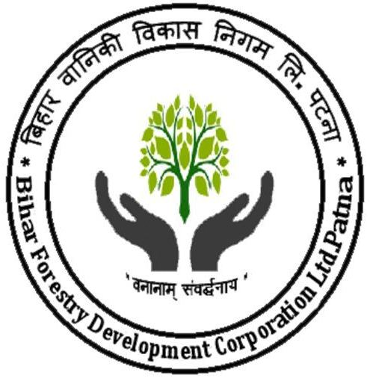

K/6, Officers Flat, New Punaichak, Patna-800023.
Email ID-dmbfdcpatna@gmail.com.
SHORT NOTICE INVITING e-TENDER

(Through e-procurement mode only over (https://eproc2.bihar.gov.in)

Tender Notice No. 05/BFDCL/e-Proc/2023-24

E-Tendering/E-Procurement is being introduced from last few years in ‘Bihar Forestry Development Corporation Limited’ for making the tendering/process of Kendu Leaves lots sale of 2023 collection season more efficient and transparent.
Agencies/contractors interested in the advance purchase of Kendu leaves lots of 2023 Kendu leaves collection season from ‘Bihar Forestry Development Corporation Limited’ are required to get themselves registered with Bihar Govt. centralized E-Procurement portal https://eproc2.bihar.gov.in/

SL No. | Scope of work | Cost of tender document  (In Rupees) | Tender processing Fee  (Non Refundable) | Earnest Money through e-payment mode (i.e. NEFT/RTGS)  (In Rupees)
SL No. | Scope of work | (inclusive of GST @18%) to be paid through e-payment mode (i.e. NEFT/RTGS/,Credit Card/Debit card) (in Rupees)
1 | 2 | 3 | 4 | 5
01. | Kendu Leaves Lots-7 Advance Sale | Rs. 10,000.00 | Rs. 590.00 | As indicated in Tender documents.
Tender Schedule/Programme:

Sl. No. | Activity | Date/Time : Duration
1. | Online Sale/Download date of Tender documents | 18.03.2023 to 25.03.2023 up to (17:00 Hrs.)
2. | Last Date/Time for submission/ uploading of offer/Bid | 27.03.2023 up to 17.00 Hrs.
3. | Date & time for opening of technical bid. | 28.03.2023 at 11:30 Hrs.
4. | Financial Bid Opening Date and Time | 28.03.2023 at 04:00 Hrs.

- Detailed descriptions of the item and instructions for submitting the offer can be downloaded from e-tender website(https://eproc2.bihar.gov.in/).

- Tender Processing Fee (TPF) amount to be paid through e-Payment mode (i.e. NEFT/ RTGS, Credit / Debit Card) only to the Bihar State Electronic Dev Corp. Patna.

- Bids along with necessary online payments (Tender Processing Fee) must be submitted through e-Procurement portal (https://eproc2.bihar.gov.in/) before the date and time specified in the NIT/RFP. The department/Tendering Authority doesn't take any responsibility for the delay / Non Submission of Tender / Non Reconciliation of online Payment caused due to Non availability of Internet Connection, Network Traffic / Holidays or any other reason."

- The bidders shall submit their eligibility and qualification details, Certificates as mentioned in section etc., in the online standard formats given in e-Procurement web site (https://eproc2.bihar.gov.in/) at the respective stage only.

- The bidders shall upload the scanned copies of all the relevant certificates, documents etc., in support of their eligibility criteria/technical bids and other certificate /documents in the e-Procurement web site (https://eproc2.bihar.gov.in/).

- The bidder shall digitally sign on the supporting statements, documents, certificates, uploaded by him, owning responsibility for their correctness/authenticity. The bidder shall attach all the required documents for the specific tender after uploading the same during the bid submission as per the tender notice and bid document.

- For support related to e-tendering process, bidders may contact at following address “e- Procurement HELP DESK - eProc 2.0 Help Desk Address: mjunction services limited RJ Complex, 2nd Floor, Canara Bank Campus, Khajpura, Ashiana Road, P.S. - Shastri Nagar, Patna 800 014, Bihar, (Toll Free Number: 1800 572 6571. Email Id: eproc2support@bihar.gov.in Working Hours: 8AM to 7PM (All days in week except few selected state holidays) or may visit the link “Vendor Info” at (https://eproc2.bihar.gov.in/).

- Contact office of ‘Bihar Forestry Development Corporation Limited’ Patna-23. for Registration/Renewal visit.

- Corrigendum/ Addendum, if any, will be published on the departmental website e-Procurement, Bihar https://eproc2.bihar.gov.in/itself.

Divisional Manager
Bihar Forestry Development Corporation Limited

